ROM – Decoders - Multiplexers homework

Paul Collado

Department of Computer Science

Montclair State University

CMPT281

Theory of Digital Machines

04/14/2015

1. Design a combinatorial logic circuit as a Read Only Memory (ROM) [Decoder plus OR gates]. The logic circuit accepts a three-bit number and generates an output binary number equal to four times the input number.

|  |  |  |  |  |  |  |  |
| --- | --- | --- | --- | --- | --- | --- | --- |
| A2 | A1 | A0 | F4 | F3 | F2 | F1 | F0 |
| 0 | 0 | 0 | 0 | 0 | 0 | 0 | 0 |
| 0 | 0 | 1 | 0 | 0 | 1 | 0 | 0 |
| 0 | 1 | 0 | 0 | 1 | 0 | 0 | 0 |
| 0 | 1 | 1 | 0 | 1 | 1 | 0 | 0 |
| 1 | 0 | 0 | 1 | 0 | 0 | 0 | 0 |
| 1 | 0 | 1 | 1 | 0 | 1 | 0 | 0 |
| 1 | 1 | 0 | 1 | 1 | 0 | 0 | 0 |
| 1 | 1 | 1 | 1 | 1 | 1 | 0 | 0 |

1. What is the size of the initial (unsimplified) ROM?

Inputs = 3

Output = 5

Size = 2^3 * 5 = 40 bits

1. What is the size of the final (simplified) ROM?

We noticed that F4 = A2, F3=A1, F2=A0, and that F1 and F0 are 0 all the way

Therefore:

the size is zero (0) because a ROM is not required for this.

1. Show in detail the final memory layout

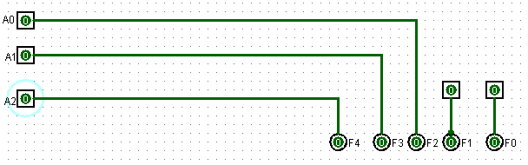

1. Design a 4x16 decoder, using 3x8 decoders



We use the enable to activate any of the two 3-8 decoders

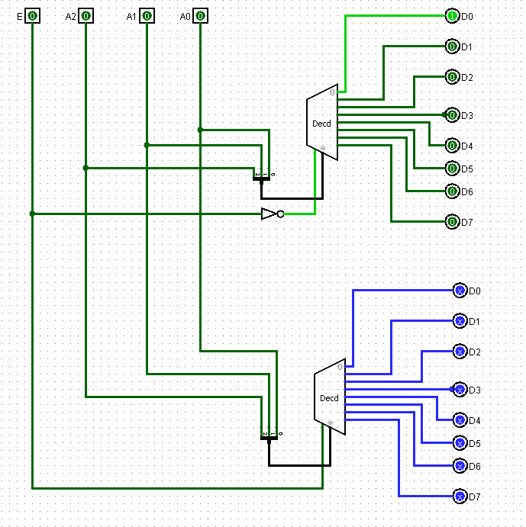

1. Design the appropriate logic circuit to perform the following
2. To encode ten separate input switches (keyboard) and output the binary value corresponding to each switch



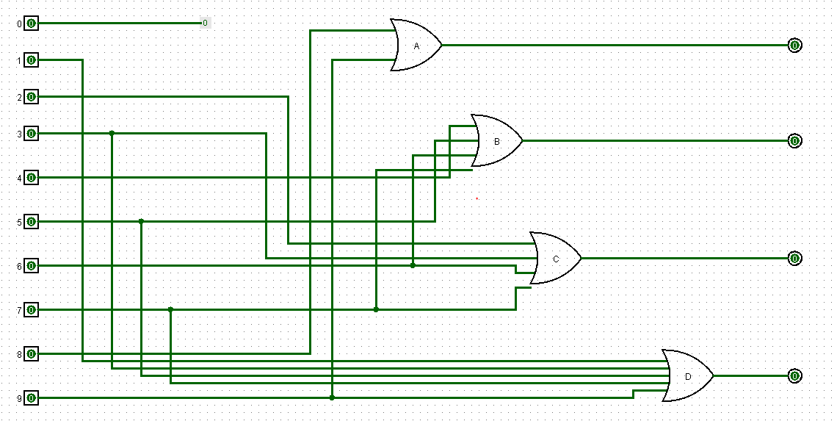

1. Interface the above logic diagram with a Seven Segment Display

This would be the complete truth table:



And this would be the complete circuit:

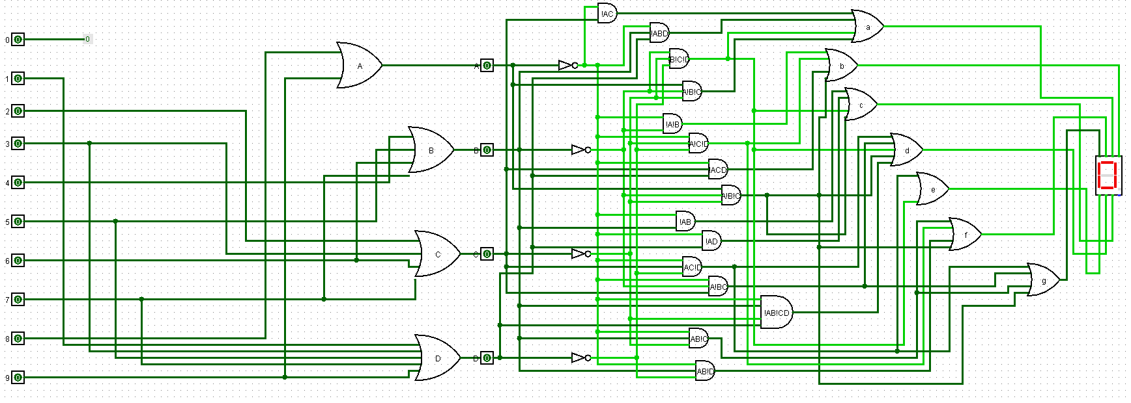

1. Design a 16 to 1 Multiplexer, with Low Enable

In order to use the Enable, I have to use two 8-1 Mux and then one 2-1 Mux to complete the circuit as a 16 to 1 Mux:

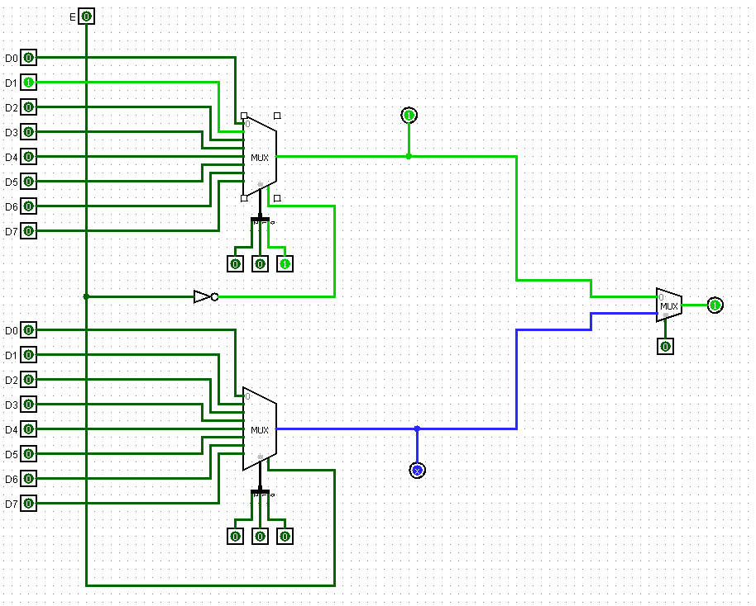

1. Design the appropriate logic circuit to connect the following 5 devices with a digital computer

|  |  |
| --- | --- |
| Device | Binary Code |
| Monitor -x | 001 |
| Plotter-A | 010 |
| Plotter-B | 101 |
| Laser Printer | 110 |
| Monitor -y | 111 |

The required circuit would be a DeMultiplexer with 3 selects and no enable is required:

